## EXERCISE-3 INCLUDING CONSTRAINTS

1.Add a table-level PRIMARY KEY constraint to the EMP table on the ID column.The constraint should be named at creation. Name the constraint my_emp_id_pk.

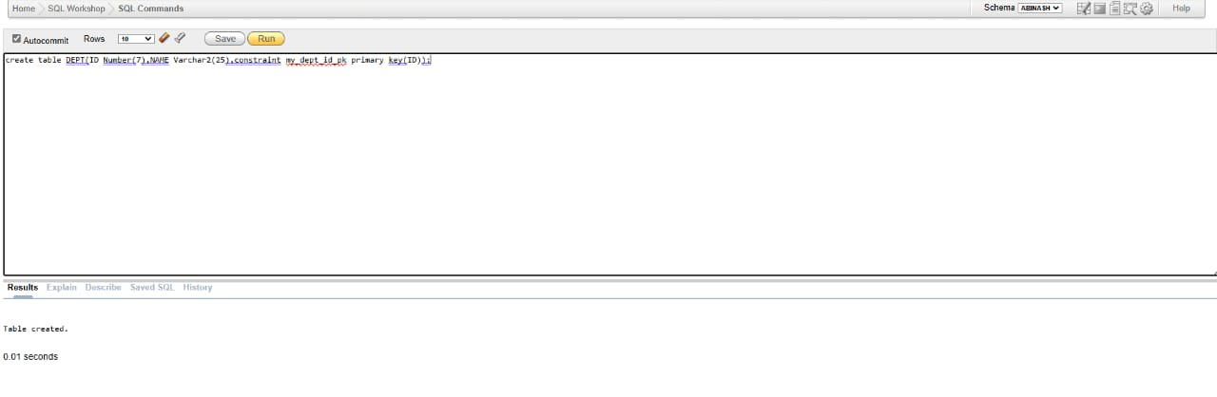

2. Create a PRIMAY KEY constraint to the DEPT table using the ID colum. The constraint should be named at creation. Name the constraint my_dept_id_pk.



3. Add a column DEPT_ID to the EMP table. Add a foreign key reference on the EMP table that ensures that the employee is not assigned to nonexistent deparment. Name the constraint my_emp_dept_id_fk.

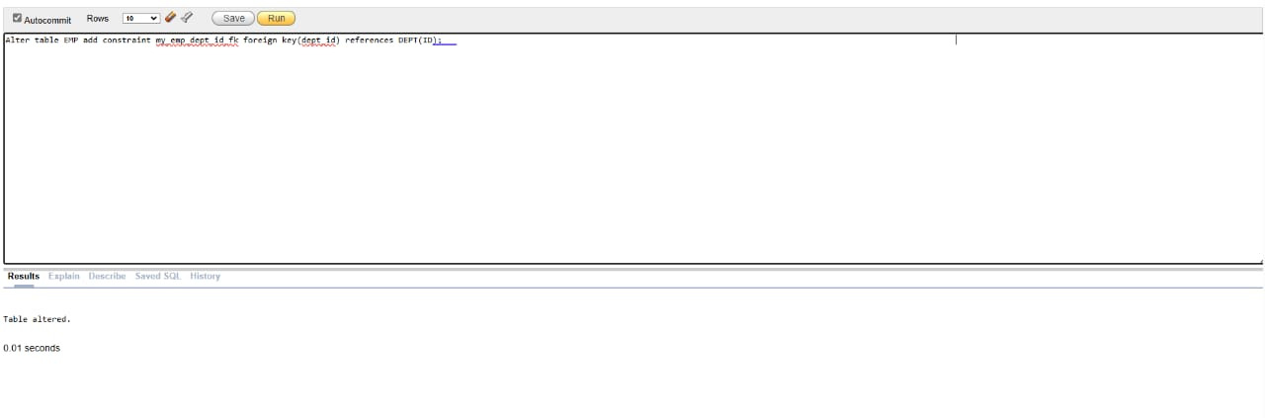

4. Modify the EMP table. Add a COMMISSION column of NUMBER data type, precision 2, scale 2. Add a constraint to the commission column that ensures that a commission value is greater than zero.

